Chapter 9 Ecosystems
extra worksheet 2: Insect adaptations

Organisms have features that suit them to the environments in which they live. Look at the photos of insects and match one for each of the statements 1 to 5 then explain why you chose that particular insect.

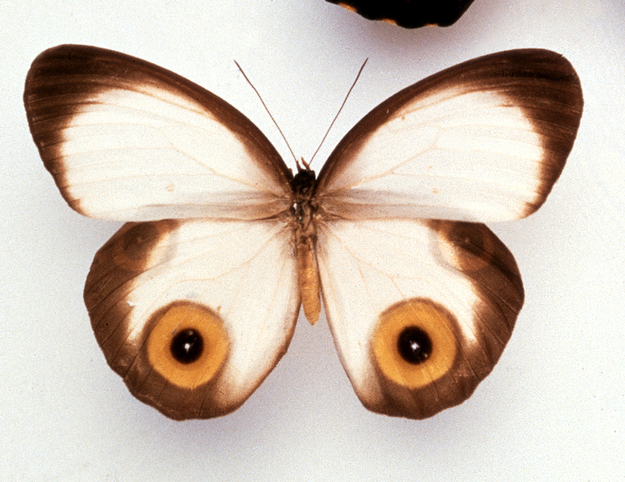
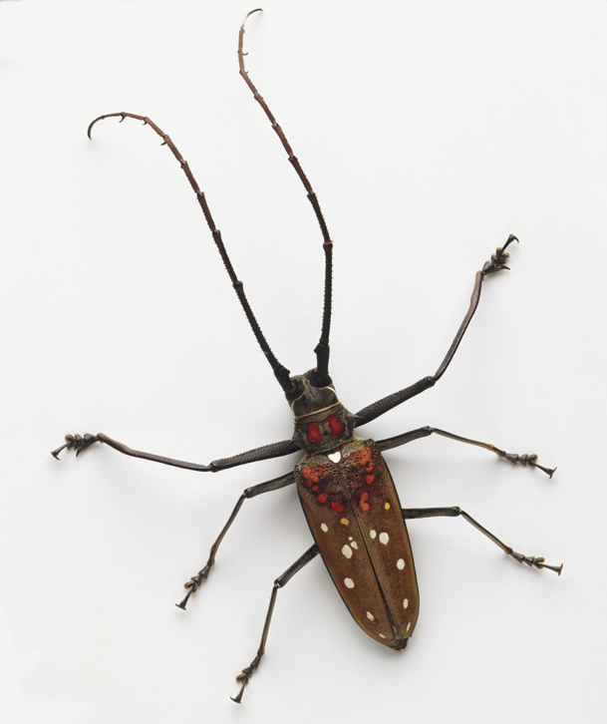
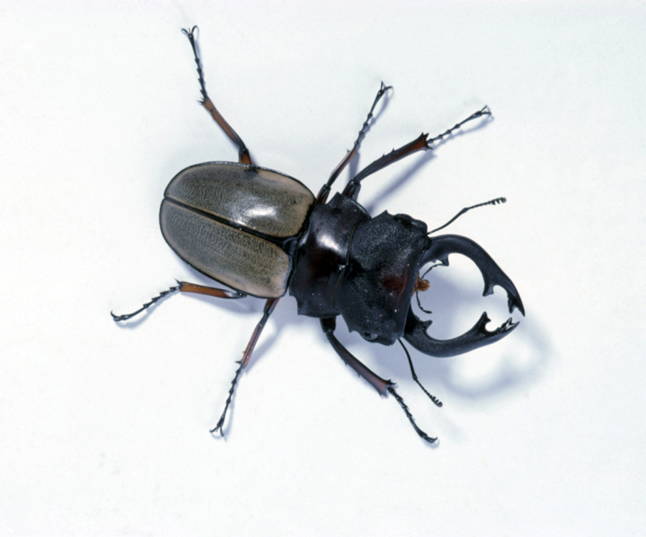

A White and brown wings.
Orange and black circles on rear wings
B Dark brown
C Black head and olive green wing covers

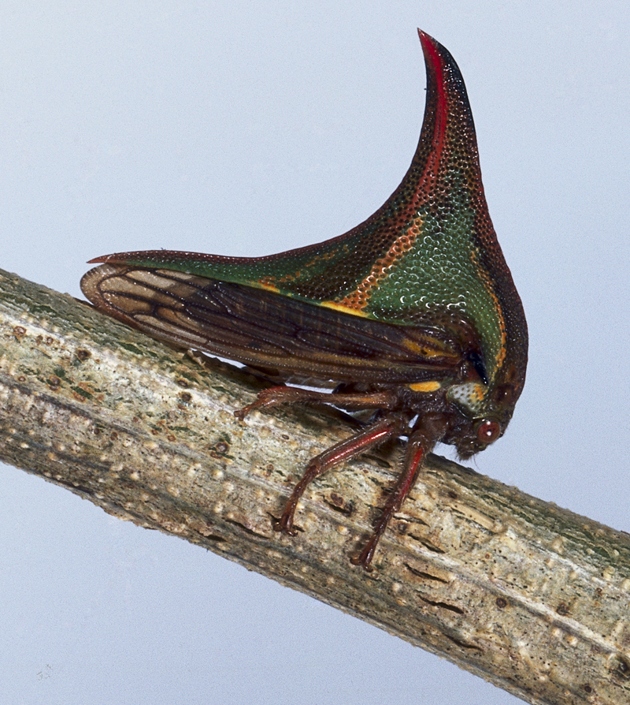
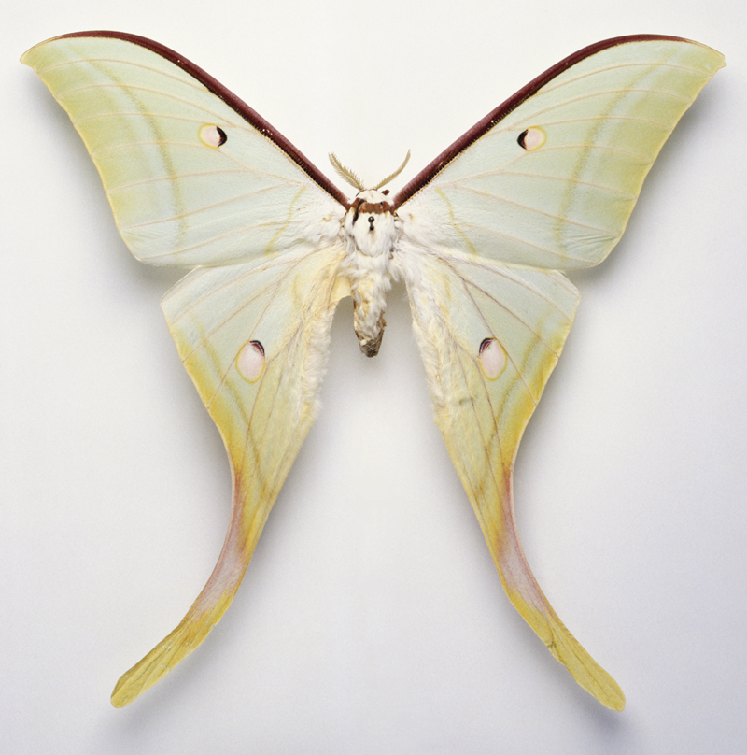

D Pale green and yellow
E Dark green and black

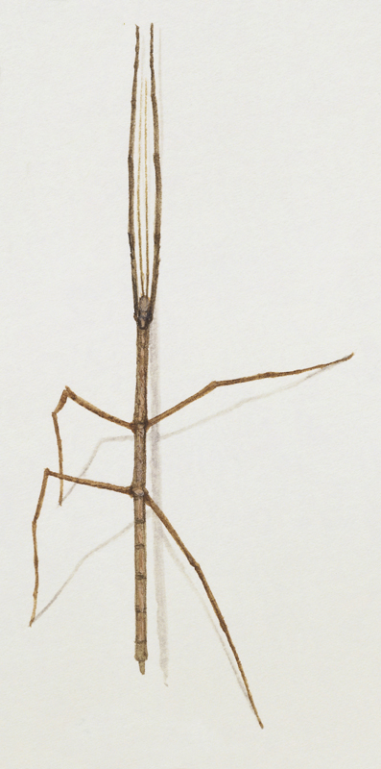

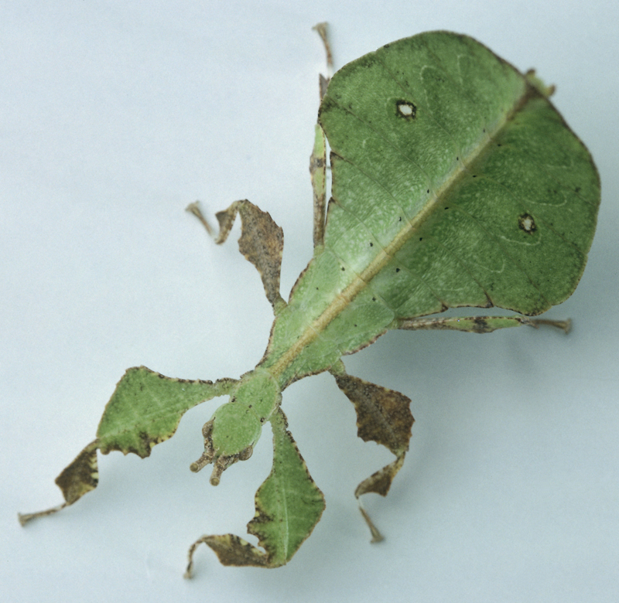
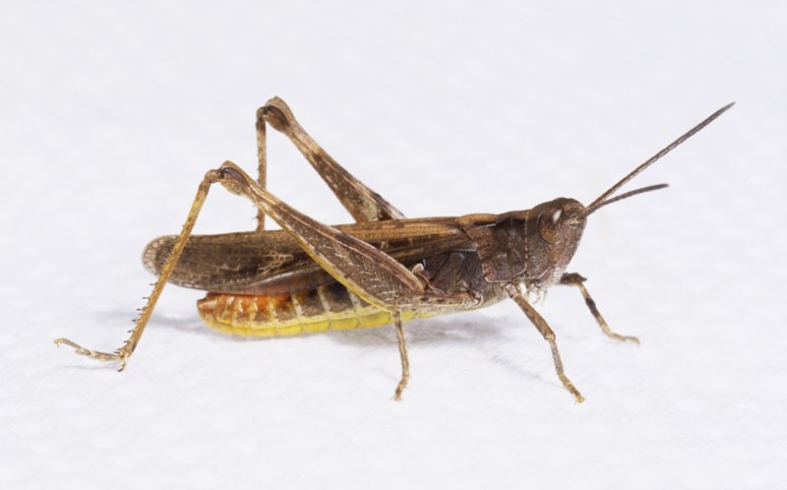

F Light green
G Medium brown
H Dark brown
1 Lives among the thin branches of trees and shrubs.
Explain why you chose this one.

2 Lives in open fields and is a good jumper.
Explain why you chose this one.

3 Lives in caves or is nocturnal (active at night).
Explain why you chose this one.

4 Scares off enemies by opening its wings.
Explain why you chose this one.

5 Lives among the leaves on trees.
Explain why you chose this one.

